**Министерство науки и высшего образования Российской Федерации Федеральное государственное бюджетное образовательное учреждение высшего образования**

**«Московский государственный технический университет имени Н.Э. Баумана**

**(национальный исследовательский университет)» (МГТУ им. Н.Э. Баумана)**

**Факультет «Информатика и системы управления»**

**Кафедра ИУ5 «Системы обработки информации и управления»**

Курс «Методы машинного обучения»

Отчет по лабораторной работе №7

«Алгоритмы Actor-Critic»

Выполнил:

студент группы ИУ5-21М Карпов Д.К.

______________

Проверил:

преподаватель каф. ИУ5

Гапанюк Ю.Е.

Москва, 2023 г.

**Цель работы:** Ознакомление с базовыми методами обучения с подкреплением на основе алгоритмов Actor-Critic.

**Задание:** На основе рассмотренных на лекции примеров реализовать любой алгоритм семейства Actor-Critic для произвольной среды.

**Описание выполнения**

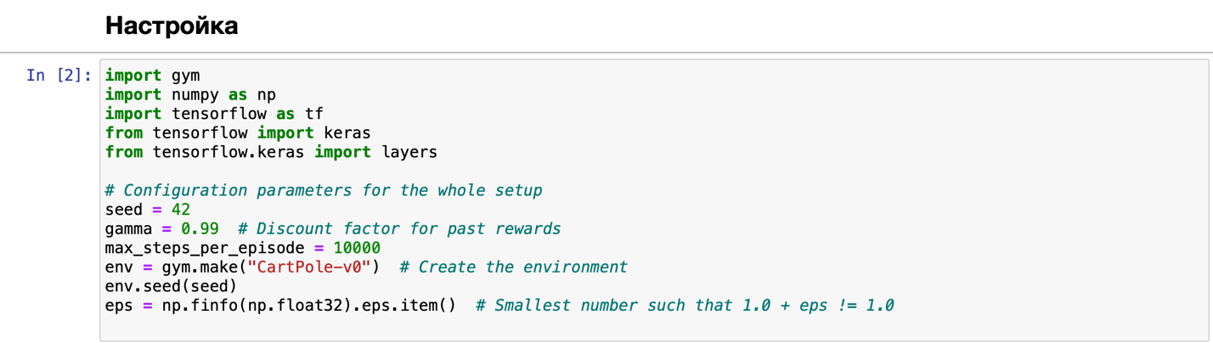

Рисунок 1 – Импорт библиотек и среды

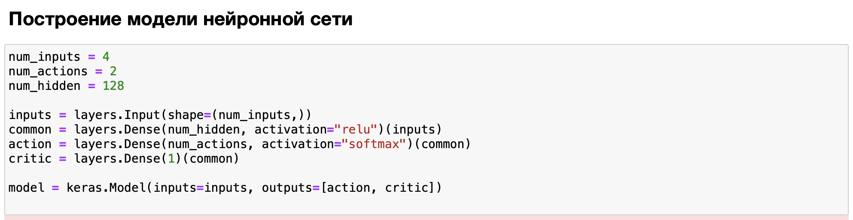

Рисунок 2 – Построение нейронной сети

**Обучение**

optimizer = keras.optimizers.Adam(learning_rate=0.01)  
huber_loss = keras.losses.Huber()  
action_probs_history = []  
critic_value_history = []  
rewards_history = []  
running_reward = 0  
episode_count = 0  
  
while True: *# Run until solved* state = env.reset()  
 episode_reward = 0  
 with tf.GradientTape() as tape:  
 for timestep in range(1, max_steps_per_episode):  
 *# env.render(); Adding this line would show the attempts  
 # of the agent in a pop up window.* state = tf.convert_to_tensor(state)  
 state = tf.expand_dims(state, 0)  
  
 *# Predict action probabilities and estimated future rewards  
 # from environment state* action_probs, critic_value = model(state)  
 critic_value_history.append(critic_value[0, 0])  
  
 *# Sample action from action probability distribution* action = np.random.choice(num_actions, p=np.squeeze(action_probs))  
 action_probs_history.append(tf.math.log(action_probs[0, action]))  
  
 *# Apply the sampled action in our environment* state, reward, done, _ = env.step(action)  
 rewards_history.append(reward)  
 episode_reward += reward  
  
 if done:  
 break  
  
 *# Update running reward to check condition for solving* running_reward = 0.05 * episode_reward + (1 - 0.05) * running_reward  
  
 *# Calculate expected value from rewards  
 # - At each timestep what was the total reward received after that timestep  
 # - Rewards in the past are discounted by multiplying them with gamma  
 # - These are the labels for our critic* returns = []  
 discounted_sum = 0  
 for r in rewards_history[::-1]:  
 discounted_sum = r + gamma * discounted_sum  
 returns.insert(0, discounted_sum)  
  
 *# Normalize* returns = np.array(returns)  
 returns = (returns - np.mean(returns)) / (np.std(returns) + eps)  
 returns = returns.tolist()  
  
 *# Calculating loss values to update our network* history = zip(action_probs_history, critic_value_history, returns)  
 actor_losses = []  
 critic_losses = []  
 for log_prob, value, ret in history:  
 *# At this point in history, the critic estimated that we would get a  
 # total reward = `value` in the future. We took an action with log probability  
 # of `log_prob` and ended up recieving a total reward = `ret`.  
 # The actor must be updated so that it predicts an action that leads to  
 # high rewards (compared to critic's estimate) with high probability.* diff = ret - value  
 actor_losses.append(-log_prob * diff) *# actor loss  
  
 # The critic must be updated so that it predicts a better estimate of  
 # the future rewards.* critic_losses.append(  
 huber_loss(tf.expand_dims(value, 0), tf.expand_dims(ret, 0))  
 )  
  
 *# Backpropagation* loss_value = sum(actor_losses) + sum(critic_losses)  
 grads = tape.gradient(loss_value, model.trainable_variables)  
 optimizer.apply_gradients(zip(grads, model.trainable_variables))  
  
 *# Clear the loss and reward history* action_probs_history.clear()  
 critic_value_history.clear()  
 rewards_history.clear()  
  
 *# Log details* episode_count += 1  
 if episode_count % 10 == 0:  
 template = "running reward: {:.2f} at episode {}"  
 print(template.format(running_reward, episode_count))  
  
 if running_reward > 150: *# Condition to consider the task solved* print("Solved at episode {}!".format(episode_count))  
 break

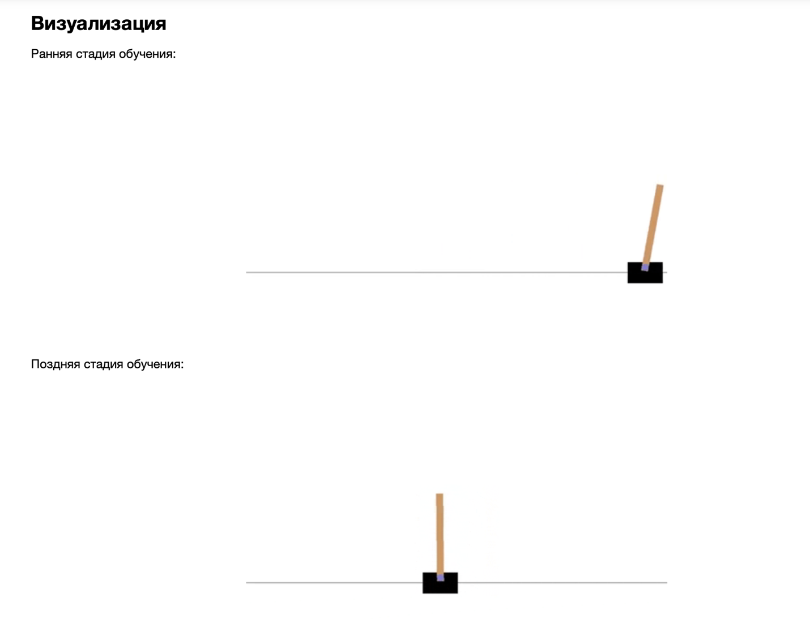

Рисунок 3 – Визуализация этапов обучения

**Вывод**

Таким образом, удалось реализовать алгоритм семейства Actor-Critic для среды обучения с подкреплением, таким образом ознакомившись с базовыми методами обучения с подкреплением на основе подобных алгоритмов.